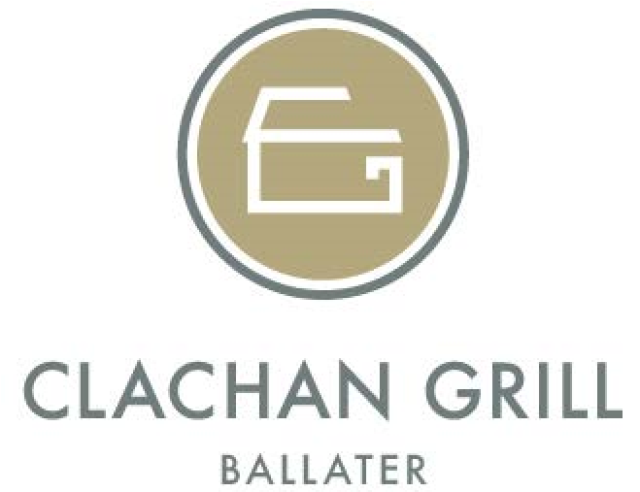
Restaurant Menu
Start Wi
SMOKED LOCH FYNE SALMON • Beetroot pickle, horseradish mayonnaise, watercress
PAVE OF CHEVRE CHEESE• Red pepper sauce, nuts & seeds, spiced pastry (V)
SCOTTISH CHICKEN LIVER PARFAIT • Toasted Brioche, Agen Prune, Orange chutney
CRISP TURKEY SCHNITZEL •Apple, capers, lemon and Strathdon blue cheese
ROASTED CELERIAC SOUP • Balmoral bread & butter (V)

Haud Gaun
GRILLED MARKET FISH •Creamed potato, tender stem broccoli, lemon pickle, crispy capers, lobster & crayfish sauce
ABERDEEN ANGUS FEATHERBLADE OF BEEF• Cranberry, Cauliflower beignet, Chantenay carrots, smoked Ayrshire bacon, red wine jus
SCOTTISH PHEASANT BREAST • pomme puree, Chestnut stuffing, morteau sausage, peppercorn sauce
RAVIOLI OF WILD MUSHROOMS• Roast butternut squash puree, Normandy Brie, truffled olive oil potatoes (V)
Aberdeen Angus Steaks
35-day dry aged steaks from Neil Menzies of Braemar, served classically with café de paris butter, house relish, hand cut chips and parmesan salad

RUMP• 8oz – Add £3.75
SIRLOIN • 10oz – Add £10
FILLET • 8oz – Add £13
T-BONE • 14oz – Add £13

RIBEYE • 10oz- Add £10
CHATEAUBRIAND Sharing for 2 only • 18oz – Add £20

Puddins
STICKY TOFFEE SPONGE • Vanilla & Clementine ice cream, lemon caramel sauce
CLASSIC VANILLA RICE PUDDING • Mulled figs, crumble
SCOTTISH CHEESES • Wafers, Arran oatcakes, chutney, poached fruits

Courses £32.50 2 Courses £29.50

